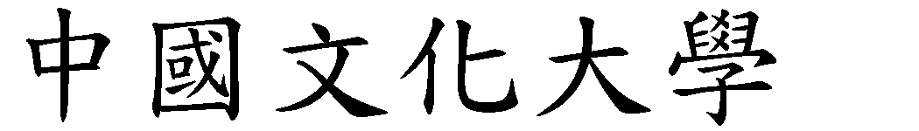 講義

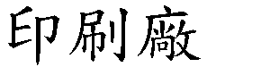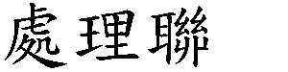

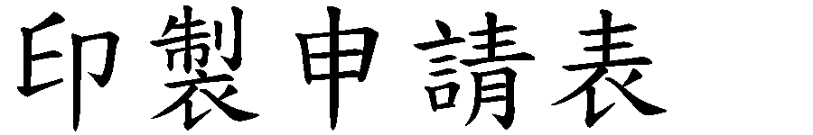

**取件處： 華義/ 華典**(講)

|  |  |  |  |  |
| --- | --- | --- | --- | --- |
|  |  | |  |  |
|  |  | |  |  |
|  |  | |  |  |
|  |  |  |  |  |
|  | 1 1 2 2 2 3 2 3  1 2 1 1 | |  |  |
|  |  | |  |  |

 講義

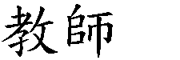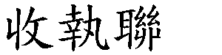

**取件處： 華義/ 華典**(講)

|  |  |  |  |
| --- | --- | --- | --- |
|  |  |  |  |

|  |  |
| --- | --- |
| 講義印製原則 |  |